**<http://doc.arcgis.com/en/arcgis-online/use-maps/view-scenes.htm>**

**Custom URL Parameters:**

In addition to the supported URL parameters, you can create your own custom URL parameter that zooms in on and shows the pop-up for a feature when the app opens. This feature is supported in the [Basic Viewer](http://www.arcgis.com/home/item.html?id=b17113eb9535427db477777f86f25d63), [Map Tools,](http://www.arcgis.com/home/item.html?id=c8a6885c0fe94ee78d9ce08d207b10cd) and [Simple Map Viewer](http://www.arcgis.com/home/item.html?id=21f8e7d08a4140d1a33b9089446dd8de) and is set up the configuration panel. Once the parameter has been set up, you can specify which feature to display by adding &name=value  to your URL where name is the name you assign your parameter and value is the value of the feature.

[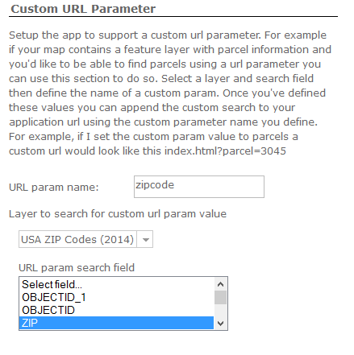](http://blogs.esri.com/esri/arcgis/files/2015/08/url.png)

To set this up:

1. Enter a name for the parameter you want to create.
2. Select the layer that contains the field for the parameter you are creating.
3. Enter the search field that you want to search with your custom URL parameter.

See custom URL parameters in use by opening the following links or by appending a new zipcode to the URL:

<http://www.arcgis.com/apps/Viewer/index.html?appid=e59de8c32e0e4ffc8afc53cff18e7be1>

<http://www.arcgis.com/apps/Viewer/index.html?appid=e59de8c32e0e4ffc8afc53cff18e7be1&zipcode=92373>

*Written by Chris Fitzpatrick, configurable apps intern.*

## Add your data in GeoPlanner

You’re almost done! Simply add these newly hosted feature layers to a GeoPlanner project.

**Step 1:** In GeoPlanner, open a project and move to the Data segment.

[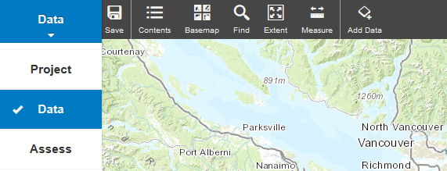](http://blogs.esri.com/esri/arcgis/files/2015/07/GeoPlanner-Add-Data.png)

**Step 2:** Click on the Add Data icon. The Search for Data dialog appears.

**Step 3:** In the Search for Data dialog, click My Content. Feature layers that you have published to ArcGIS Online can be found here. Search for your feature layers by name or tags.

**Step 4:** Click the Add button to add a layer to GeoPlanner!

## <http://doc.arcgis.com/en/arcgis-online/use-maps/view-scenes.htm>

## [Esri Maps for Office 3.1 Released!](http://blogs.esri.com/esri/arcgis/2015/06/22/esri-maps-for-office-3-1-released/)

‎Tuesday, ‎23 ‎June ‎2015, ‏‎1:36:07 a.m. | Kathie Fitzgerald

We are pleased to announce the release Esri Maps for Office v3.1.

This release of Esri Maps for Office includes the following updates:

* Localized support for 27 languages
* Workflow improvements
* Bug fixes
* Updated online help

Visit [esri.com](http://www.esri.com/software/arcgis/arcgisonline/apps/download) to download and install Esri Maps for Office 3.1.

For product documentation and other information about Esri Maps for Office, see the Esri Maps for Office [web help](http://doc.arcgis.com/en/maps-for-office/) and be sure to visit [GeoNet](https://geonet.esri.com/community/gis/analysis/esri-maps-for-location-analytics/content?filterID=contentstatus%5bpublished%5d~objecttype~objecttype%5bthread%5d&filterID=contentstatus%5bpublished%5d~tag%5b_office%5d) to get help from the community.

~The Esri Maps for Office team

[Comments (0)](http://blogs.esri.com/esri/arcgis/2015/06/22/esri-maps-for-office-3-1-released/#comments)

**Tip #4: How to map change (over time)**

If you have data for multiple time periods you might want to understand how things are changing over time. In the example below, you can see which US counties grew and shrank in population, and which ones are changing the fastest. Rather than make 2 maps, for the 2 time periods, and expect your readers to do the math themselves (an almost impossible task), why not create a ratio of the two years using the “Divided By” pulldown to normalize the data.

In this case, Population 2012 was divided by Population 2010. A value of 1.0 means there was no change, numbers bigger than 1 mean growth, and less than 1.0 means population loss. This approach works for any numerical data from two time periods, not just population data. The ratio approach also work to compare two variables from the same time period, such as number of males to females, or one political party versus another.

**Hint:** These kinds of change maps are perfect for the Above-and-Below theme.

[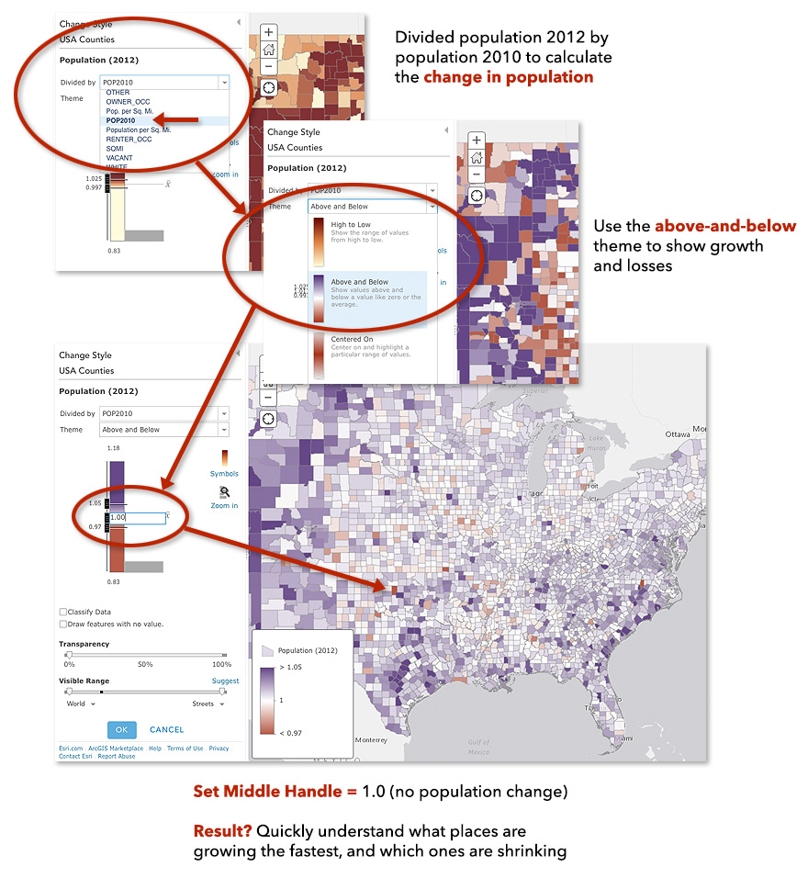](http://blogs.esri.com/esri/arcgis/files/2019/06/Tip3.jpg)

**Tip #5: Explore advanced transparency effects**

Sometimes you might want finer control over the transparency of your map symbols, more than can be achieved with just the layer transparency, since it applies to everything in the layer. A favorite technique of cartographers is to apply semi-transparent fills and solid strokes to Counts and Amounts (Size) maps.

[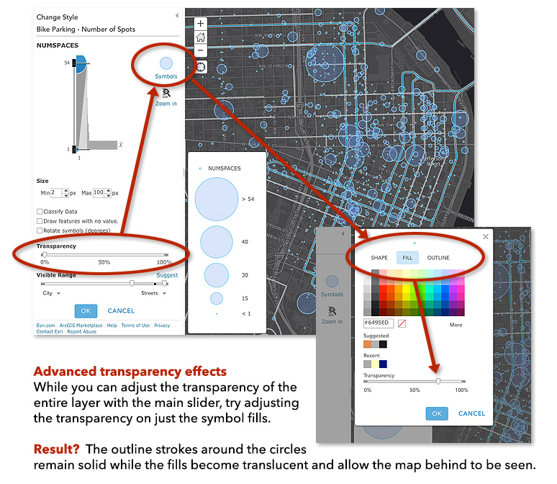](http://blogs.esri.com/esri/arcgis/files/2019/06/Tip4.jpg)

**Tip #6: Change All Symbols versus Change One Symbol**

Categorical data is best mapped as Unique Value maps. Categorical data includes things like tree species, fuel types, and political parties: they’re different categories of things. To change the look of a single category/symbol (e.g., change the shape, color, size) click the symbol right beside the class name. To change the look of all symbols (e.g., change all classes from circles to squares) click the Symbols button (the three color boxes).

[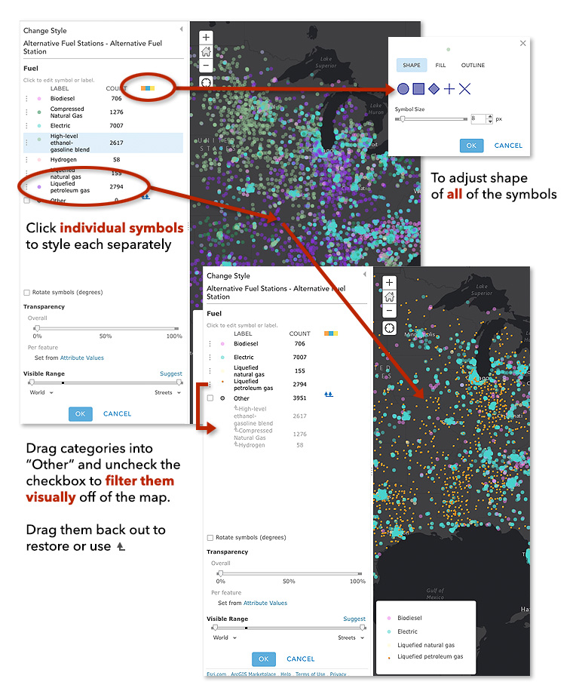](http://blogs.esri.com/esri/arcgis/files/2019/06/Tip6.jpg)

**Tip #7: Advanced Feature – Rotating Point Symbols**

When working with point features that have numeric information, it is quite easy to map the size of the symbol using one attribute (say, wind speed) and then rotate those symbols proportional to some other attribute (say, wind direction). When combined with the position of the symbol, each point of the map communicates three pieces of information.

**Hint:** Make sure to use point symbols that look different when rotated, like arrows!

[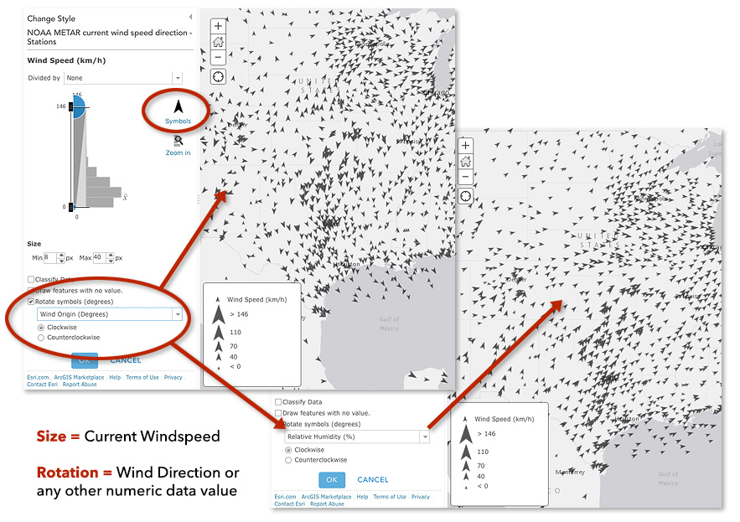](http://blogs.esri.com/esri/arcgis/files/2019/06/Tip7.jpg)

[Comments (0)](http://blogs.esri.com/esri/arcgis/2015/06/16/smart-mapping-part-5-tips-and-tricks/#comments)